Answer the following questions for each picture:
- What does this picture show?
- Explain the message in this picture.
- What are the two sides represented?
- What side is being supported by this picture/cartoon?
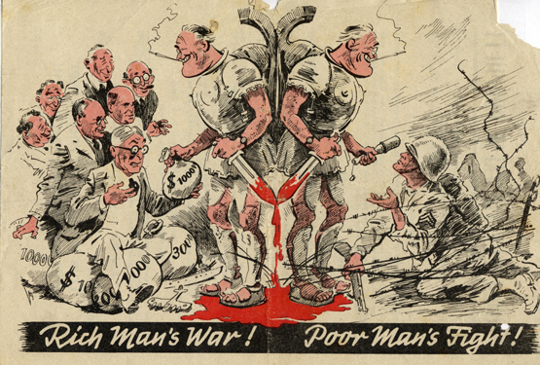
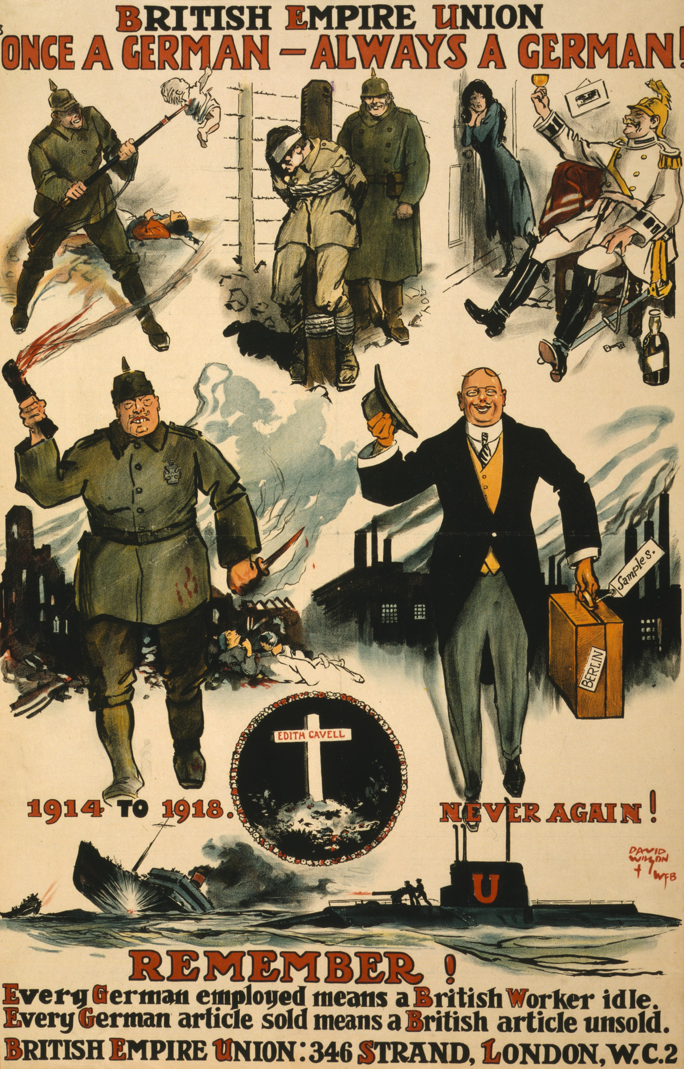
Top Picture
1.
2.
3.
4.

Bottom Picture
1.
2.
3.
4.

