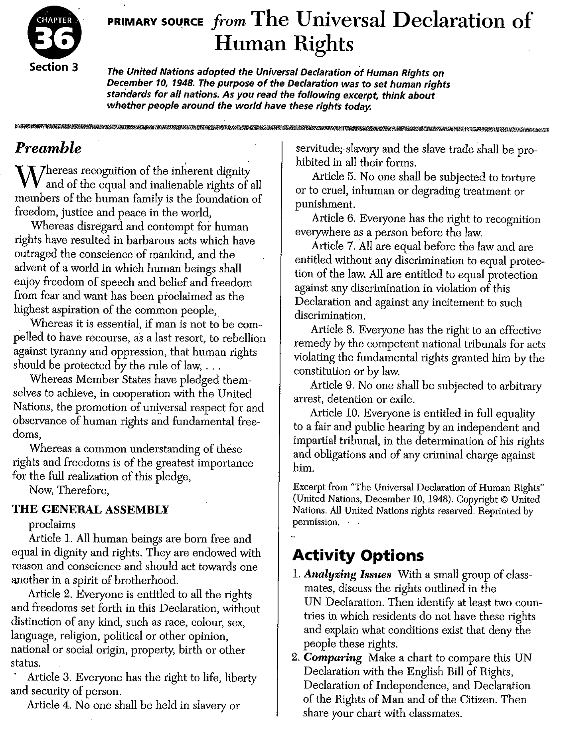
- Country #1-
Country #2-

2.
Universal Declaration of Human Rights | (ReWordify.com)

