The Middle-Ages
The Early Middle-Ages
CHARLEMAGNE
Which well-known family did Charlemagne belong to? ____________________________
What was the foundation for much of his success? ________________________________
Who did Charlemagne protect numerous times? ___________ and ___________________
What did this person name Charlemagne? _______________________________________________________
What did Charlemagne use to help him rule? ______________ ( ___________________________________ )
How did Charlemagne ensure these people were doing their job? _____________________________________ _________________________________________________________________________________________
ACHIEVEMENTS
Politics

Education

Religion

Law

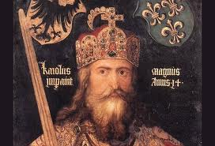

The Feudal System
What is the Feudal System? _______________ and _______________ system based on granting _________ in exchange for ______________, _______________________________ and other services.

Why did they need a new system? To help protect against ________________________.

LORD/KING
∙ ∙
NOBLES
∙ ∙
What did the Nobles provide for the King?
KNIGHTS
Nobles trained soldier to defend the castles
∙ Knights had to ______________________ ∙ Remain _____________________ ∙ Give _________________
Fief Vassel

**
Manorial System

Generally owned by wealthy ______________ or _________________.
PEASANTS
∙
SERFS
∙ ∙ were NOT _____________
∙ workers who were ___________________________ ∙ Serfs could NOT ____________________
∙

LIFE ON THE MANOR

- Each manor wanted to be __________________________: included __________________________ _________________________________________________________________________________
Look at pg. 385 and answer the questions about “A Typical Manor”:
DAILY LIFE IN THE MIDDLE-AGES
LIFE IN THE CASTLE VS. LIFE IN THE VILLAGE

Life was not easy either way, most people died young

