World History Benchmark Test #2

- During the Neolithic Era, which change first resulted in the creation of settled communities?
  - Invention of written language
  - Development of agriculture
  - Specialization of labor
  - Use of pottery

------------------------------------------------------------------------------------------------------------

- Which factor had the greatest effect on the movements of early nomadic societies?
  - Mineral deposits
  - Religious beliefs
  - Survival needs
  - Tribal treaties

------------------------------------------------------------------------------------------------------------

- Which geographic features determined the location of the early civilizations of Egypt, Mesopotamia, China, and India?
  - Oceans and coastlines
  - Rivers and valleys
  - Fertile soils and plains
  - Rainy seasons and forests

------------------------------------------------------------------------------------------------------------

- The defining characteristic of polytheistic religions is the idea that…
  - There is an eternal struggle between good and evil
  - Beings undergo many cycles of rebirth
  - Past actions control the destiny of each person
  - There are many gods and goddesses in existence

------------------------------------------------------------------------------------------------------------

- The Vedas and the Upanishads are sacred writings of…
  - Hinduism
  - Judaism
  - Zoroastrianism
  - Buddhism

------------------------------------------------------------------------------------------------------------

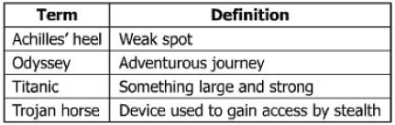
- Which statement best describes the origin of the terms above?
  - They are events from Roman history.
  - They are found in Babylonian legends.
  - They are taken from Greek mythology.
  - They are actions of Egyptian gods.

------------------------------------------------------------------------------------------------------------

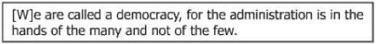
- This is a quotation from…
  - Pericles
  - Homer
  - Pythagoras
  - Hippocrates

------------------------------------------------------------------------------------------------------------

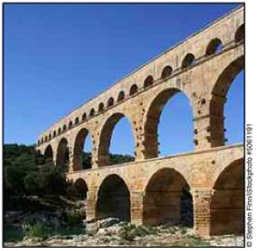
- What was the purpose of the structure in the picture above?
  - To make travel easier
  - To carry water
  - To practice a religion
  - To defend a city

------------------------------------------------------------------------------------------------------------

- Emperor Constantine influenced the traditions of Western civilization by…
  - Sending Roman soldiers to the Middle East
  - Legalizing Christianity within the Roman Empire
  - Codifying Roman law in the Middle East
  - Unifying Europe by founding the Holy Roman Empire

------------------------------------------------------------------------------------------------------------

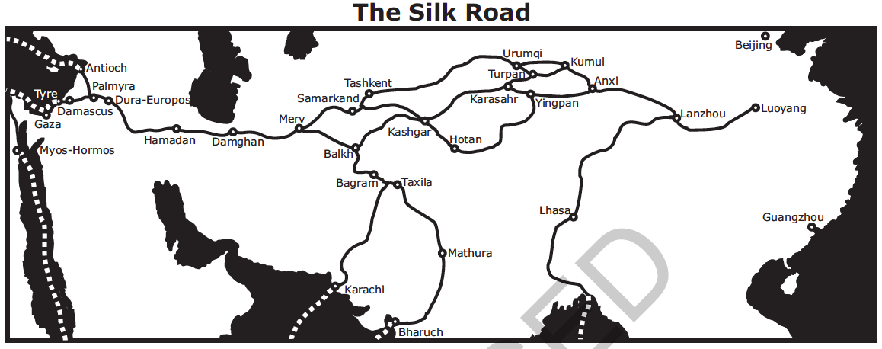
- According to the map above, how was the Silk Road associated with the development of cities?
  - Increased trade along this route helped to establish cities within major empires.
  - The development of many cities created a need for better roads.
  - The Silk Road was built as an alternative to trade between large cities by the sea.
  - European governments promoted free trade between major cities.

------------------------------------------------------------------------------------------------------------

- In the Middle Ages, European monarchs claimed to rule by “divine right”. What purpose was served by this claim?
  - It enabled the separation of church and state.
  - It enabled rulers to seize church lands.
  - It demonstrated that religion was stronger than political power.
  - It strengthened the monarch’s authority to rule.

------------------------------------------------------------------------------------------------------------

- How did the printing revolution contribute to increased global interaction?
  - By making texts available to broader audiences, leading to the spread of new ideas
  - By creating interchangeable parts that made repairing the printing press easier
  - By mass producing the press to make it available to small towns
  - By using color to gain the interest of more people

------------------------------------------------------------------------------------------------------------

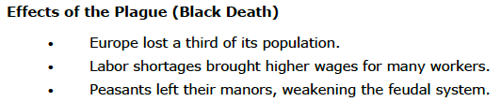
- Which conclusion about effects of the plague can be drawn from the listed information?
  - Catastrophic events can trigger changes in human institutions.
  - Tragic events strengthen religion as people seek answers in their faith.
  - People seek the comfort of traditional, familiar ways following traumatic events.
  - Societies flourish during many types of disasters and epidemics.

------------------------------------------------------------------------------------------------------------

- Which is an effect of European exploration of the Americas?
  - Germany extended its New World Empire.
  - Spain dominated North and South America.
  - Africans were enslaved to work in mines and on plantations.
  - American Indians maintained resistance to African and Eurasian diseases.

------------------------------------------------------------------------------------------------------------

- What was a significant result of European exploration through the Columbian Exchange?
  - Europeans became dependent on crops from America.
  - The bubonic plague spread throughout Europe.
  - European diseases caused millions of deaths among American Indians.
  - Raw materials from America became very expensive due to scarcity.

------------------------------------------------------------------------------------------------------------

- How did the new ideas and scientific advances of the Renaissance challenge the Catholic Church?
  - New Renaissance universities, which emphasized scientific research, gave most citizens educational opportunities that challenged the religious institution.
  - Individualism and humanist ideas from the Renaissance challenged citizens too seek answers for themselves rather than from religious institutions.
  - New merchant guilds formed by the middle class owed allegiance to the leaders of the Renaissance rather than the Catholic Church.
  - Feudal noble landowners accepted the scientific advances of the Renaissance that were supported by the Catholic Church.

------------------------------------------------------------------------------------------------------------

- Which institution in Western Europe had the most power during the Middle Ages?
  - The Church
  - Merchant guilds
  - The feudal system
  - Roman universities

------------------------------------------------------------------------------------------------------------
- The cause of the split in Islam after Muhammad’s death was a difference of opinion concerning –
  - Expansion
  - Leaders
  - Prayer
  - Pilgrimages

------------------------------------------------------------------------------------------------------------

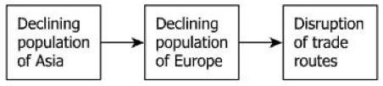
- This sequence of events was caused by the –
  - Beginning of the Crusades
  - Fall of the Roman Empire
  - Hundred Years’ War
  - Bubonic Plague

------------------------------------------------------------------------------------------------------------

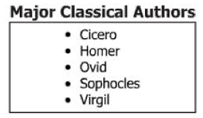
- During the Renaissance, these authors were most often studied by –
  - Bankers
  - Humanists
  - Feudal lords
  - Parish priests

------------------------------------------------------------------------------------------------------------

“Litter of the past is the basis of archaeology. The coins, the pottery, the textiles and the buildings of bygone eras offer us clues as the how our (early ancestors) behaved, how they ran their economy, what they believed in and what was important to them. What archaeologist retrieve from excavations are images of past lives…. (These images) are pieced together slowly and painstakingly from the information contained in objects found.”

Richard Leakey in The Making of Mankind

- According to Richard Leakey, what is the job of the archaeologist?
  - To study coins to learn about an economy
  - To clean out caves where early ancestors lived
  - To create images of coins, pottery and textiles
  - To examine artifacts found at a location

- What term applies to the behaviors, economic activities, and beliefs referred to by Richard Leakey?
  - Culture
  - Civilization
  - Case study
  - Artifacts

------------------------------------------------------------------------------------------------------------

“The epilogue laws of justice which Hammurabi, the wise king, established; a righteous law, and pious statute did he teach the land….the decisions which I have made will this inscription show him; let him rule his subjects accordingly, speak justice to them, give right decisions, root out the miscreants and criminals from this land, and grant prosperity to his subjects. Hammurabi, the king of righteousness, on whom Shamash has conferred right (or law) am I. My words are well considered; my deeds are not equaled; to bring low those that were high; to humble the proud, to expel insolence.”

Code of Hammurabi, Epilogue

- How did implementation of codified laws such as the Code of Hammurabi affect the people of ancient societies?
  - It unified the various peoples and laws within the empire.
  - It reduced the authority of the king over the citizens.
  - It limited the role of government in the lives of citizens.
  - It established the separation of government and religion.

------------------------------------------------------------------------------------------------------------

“Guide the people with governmental measures and control or regulate them by the threat of punishment, and the people will try to keep out of jail, but will have no sense of honor or shame. Guide the people by virtue and control or regulate them by li (moral rules and customs), and the people will have a sense of honor and respect.”

Confucius, Analects 2.3

- Which phrase best describes Confucius’s belief about human nature and lawful behavior?
  - People are naturally moral and can control their behavior on their own.
  - People are best controlled by fear.
  - People learn good behavior by example.
  - People cannot be controlled by any means.

- Which of the following rulers might have held a similar belief to the quote above?
  - Shi Huangdi c. King Ashurbanipal
  - Cyrus d. Ramses II

------------------------------------------------------------------------------------------------------------

“Where ought the sovereign power of the state to reside?...The state aims to consist as far as possible of those who are alike and equal, a condition found chiefly among the middle section….The middle class is also the steadiest element, the least eager for change. They neither cover, like the poor the possessions of others, nor do others covert their, as the poor covet those of the rich….Tyranny often emerges from an over-enthusiastic democracy or from an oligarchy, but much more rarely from middle class constitutions.”

Aristotle, Politics

- Why does Aristotle support the middle class as the location of power?
  - He finds poor people too backward to rule.
  - He thinks the rich are too greedy.
  - The middle class is very enthusiastic about democracy.
  - The middle class is steady and is less eager for change.

- According to Aristotle, what often emerges from an “over-enthusiastic democracy”?
  - Tyranny c. Monarchy
  - Oligarchy d. Aristocracy

------------------------------------------------------------------------------------------------------------

“He who trusts any man with supreme power gives it to a wild beast, for such his appetite sometimes makes him; passion influences those in power, even the best of men, but law is reason without desire….”

Aristotle

- Which feature of modern Western democratic government reflects Aristotle’s views as given above?
  - The direct election of members of the legislature
  - The power of the courts to review the law
  - The granting of emergency powers to the chief executive
  - The requirement that government actions must adhere to the law

------------------------------------------------------------------------------------------------------------

“Kalinga was conquered by his Sacred and Gracious Majesty when he had been consecrated eight years. 150,000 persons were thence carried away captive, 100,000 were slain, and many times that number died….Thus arose his Sacred Majesty’s remorse for having conquered the Kalingas, because the conquest of a country previously unconquered involves the slaughter, death, and carrying away captive of the people.”

Asoka in A History of Modern India by Percival Spear

- Why was Asoka remorseful about the campaign against Kalinga?
  - His army was not victorious.
  - The battle took too long to fight.
  - Many people were killed or made captives.
  - He was not able to play a more active role in the battle.

- What did the conquest of Kalinga cause Asoka to realize about the nature of war?
  - War leads to the deaths of innocent people.
  - War is the best means possible to expand an empire.
  - War cannot be avoided.
  - War is very expensive to fight.

------------------------------------------------------------------------------------------------------------

“All merchants, unless they have been previously and publically forbidden, are to have safe and secure conduct in leaving and coming to England and in staying and going through England both by land and by water to buy and to sell, without any evil exactions, according to the ancient and right customs, save in time of war, and if they should be from a land at war against us and be found in our land at the beginning of the war, they are to be attached without damage to their bodies or goods until it is established by us or our Chief Justiciar in what way the merchants of our land are threated who at such a time are found in the land that is at war with us, and if our merchants are safe there, the other merchants are to be safe in our land.”

Magna Carta, 1297

- Based on this passage from the Magna Carta, which basic rights were improved by the English barons?
  - Trading rights
  - Rights of the accused
  - Civil rights
  - Religious rights

------------------------------------------------------------------------------------------------------------

In the following experpt, a Portugueses messenger addresses a local Hindu king of southern India in 1509. The messenger asks for help in taking the Indian trading port of Calicut from Ottoman and Arab control:

“The King of Portugal commands me to render honour and willing service to all the Gentile Kings of this land…they are to be well treated by me, neither am I to take their ships nor thie r merchandise; but I am to destroy the Moors, with whom I wage incessant war, as I know he also does… I am prepared and ready to help him with the fleets and armies of the King…as often as hel shall desire me to do so; and I likewise, for my part, expect that he will help us with his army, towns, harbours, and munitions, and with everything that I require from his kingdom; and the ships which navigate to his ports may pass safely throughout all the Indian sea…”

- Which conclusion about the effect of increased trade is supported by the above excerpt?
  - Overseas trade routes were too crowded and dangerous to produce profitable returns.
  - Overseas trade routes encouraged cooperation between powerful empires against small kingdoms and city-states.
  - Competition over Indian Ocean trade encouraged global empires to form military alliances with local rulers.
  - Competition over Indian Ocean trade led to regional wars between European navies and Indian city-states.

------------------------------------------------------------------------------------------------------------

“One should read histories, study biographies and the experiences of nations. By doing this, it will be as though, in his short life space he lived contemporaneously with peoples of the past, was on intimate terms with them, and knew the good and the bad among them… You should model your conduct on that of the early Muslims. Therefore, read the biography of the Prophet, study his deeds and concerns, follow in his footsteps, and try your utmost to imitate him.”

Abd al-Latif quoted in A History of the Arab Peoples

- Why does al-Latif advocate studying history?
  - Because history repeats itself
  - Because history provides insight into the lives of past peoples
  - Because studying history is a good intellectual exercise
  - Because studying history is required of all Muslims

- Why does he want people to study the life of Muhammad?
  - Because Muhammad is a great historical figure
  - Because Muslim law require it
  - To learn to be like the Prophet
  - To learn about cultural blending

------------------------------------------------------------------------------------------------------------

“There was a knight, a most distinguished man,
Who from the day on which he first began
To ride abroad had followed chivalry,
Truth, honor, generous, and courtesy.
He had done nobly in sovereign’s war
And ridden in battle, no man more,
As well as Christian in heathen places
And ever honored for his noble graces.

Geoffrey Chaucer, The Canterbury Tales

- Which of these phrases does not characterize the knight Chaucer describes?
  - A skilled fighter
  - A devoted Christian
  - A young man
  - A well-traveled warrior

- What qualities of knighthood do you think are missing from Chaucer’s description?
  - That a knight was of noble birth
  - That a knight was a skilled warrior
  - That a knight adored his chosen lady
  - That a knight devoted himself to his heavenly Lord

------------------------------------------------------------------------------------------------------------

“The king to the sheriff of Northampton, greeting. Whereas we wish to have a conference and discussion with the earls, barons, and other nobles of our realm concerning the provisions of remedies for the dangers that in these days threaten the same kingdom…we command and firmly enjoin you that without delay you cause two knights, of the more discreet and more capable of labor, to be elected from the aforesaid county, and two citizens from each city of the aforesaid county, and two burgesses from each borough, and that you have them come to us…to do whatever in the aforesaid matters may be ordained by common counsel.”

King Edward I in a letter to sheriffs in England

- Why is the king calling a meeting of Parliament?
  - He wants to raise taxes.
  - He wants to select new knights.
  - He wants to discuss threats to the kingdom.
  - He wants to give advice to the leaders.

- How will the representatives be chosen?
  - They will be selected by the sheriff.
  - They will be elected by the people.
  - They will be selected by the lords.
  - They will be elected by the knights

------------------------------------------------------------------------------------------------------------

“We return thanks to our mother, the earth, which sustains us. We return thanks to the rivers and streams, which supply us with water… We return thanks to the corn, and to her sisters, the beans, and squashes, which give us life… We return thanks to the sun, that he has looked upon the earth with a beneficent eye… We return thanks to the Great Spirit… who directs all things for the good of his children.”

Quoted in In the Trail of the Wind

- How did the Iroquois feel about nature?
  - They felt angry at nature.
  - They felt grateful to nature.
  - Nature was seen as a mere tool to the Iroquois.
  - Nature played little part in the lives of the Iroquois.

------------------------------------------------------------------------------------------------------------

“A prince must also show himself a lover of merit [excellence], give preferment [promotion] to the able, and honour those who excel in every art. Moreover he must encourage his citizens to follow their callings [professions] quietly, whether in commerce, or agriculture, or any other trade that men follow… [The prince] should offer rewards to whoever does these things, and to whoever seeks in any way to improve his city or state.”

Niccolo Machiavelli, The Prince

- What phrase best describes the advice given by Machiavelli?
  - Rule with and iron hand in a velvet glove.
  - Do not give our subjects any freedoms.
  - Reward hard work and patriotism.
  - To retain your rule, you must interfere in the lives of your subjects.

------------------------------------------------------------------------------------------------------------

The question you read next will require you to answer in writing.

- European nations such as Portugal, Spain, France, and England led explorations to new lands in the sixteenth and seventeenth centuries. These voyages extended from the coast of Africa to the Americas and beyond. Explain how the voyages of exploration affected global interactions and now patterns of trade. Give two examples: one for impact on global interactions and another for new patterns of trade.

