World History Benchmark Test #1

- During the Neolithic Era, which change first resulted in the creation of settled communities?
  - Invention of written language
  - Development of agriculture
  - Specialization of labor
  - Use of pottery

------------------------------------------------------------------------------------------------------------

- Which factor had the greatest effect on the movements of early nomadic societies?
  - Mineral deposits
  - Religious beliefs
  - Survival needs
  - Tribal treaties

------------------------------------------------------------------------------------------------------------

- Which geographic features determined the location of the early civilizations of Egypt, Mesopotamia, China, and India?
  - Oceans and coastlines
  - Rivers and valleys
  - Fertile soils and plains
  - Rainy seasons and forests

------------------------------------------------------------------------------------------------------------

- The defining characteristic of polytheistic religions is the idea that…
  - There is an eternal struggle between good and evil
  - Beings undergo many cycles of rebirth
  - Past actions control the destiny of each person
  - There are many gods and goddesses in existence

------------------------------------------------------------------------------------------------------------

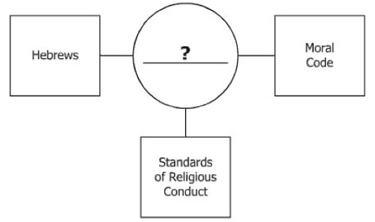
- Which of these best completes the diagram above?
  - Vedas
  - Upanishads
  - Twelve Tablets
  - Ten Commandments

------------------------------------------------------------------------------------------------------------

- How did geographic features influence the diffusion and settlement of both the Phoenician and Greek traders?
  - Both had access to the Mediterranean Sea.
  - The monsoon winds made ocean travel easier.
  - The arid climate encouraged migration.
  - Russia’s rivers provided ease of travel.

------------------------------------------------------------------------------------------------------------

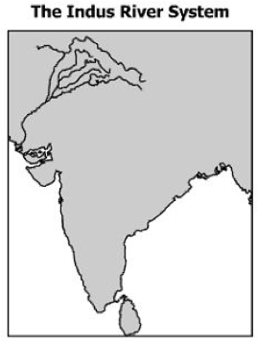
- Which empire is associated with this river system in the map above?
  - Gupta Empire
  - Chinese Empire
  - Phoenician Empire
  - Babylonian Empire

------------------------------------------------------------------------------------------------------------

- The Vedas and the Upanishads are sacred writings of…
  - Hinduism
  - Judaism
  - Zoroastrianism
  - Buddhism

------------------------------------------------------------------------------------------------------------

- According to the Mandate of Heaven, a Chinese emperor could remain in power as long as he…
  - Obeyed the priests
  - Controlled the army
  - Governed as a just ruler
  - Conquered new territories

------------------------------------------------------------------------------------------------------------

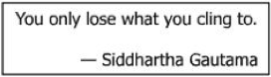
- The quotation above best represents the religious views of…
  - Hindus
  - Zoroastrians
  - Buddhists
  - Jews

------------------------------------------------------------------------------------------------------------

- Living in harmony with nature is an important part of Chinese culture primarily because of…
  - Hinduism
  - Taoism
  - Buddhism
  - Confucianism

------------------------------------------------------------------------------------------------------------

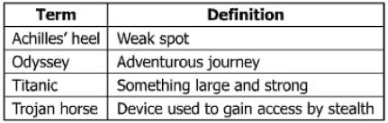
- Which statement best describes the origin of the terms above?
  - They are events from Roman history.
  - They are found in Babylonian legends.
  - They are taken from Greek mythology.
  - They are actions of Egyptian gods.

------------------------------------------------------------------------------------------------------------

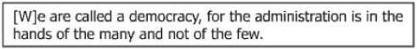
- This is a quotation from…
  - Pericles
  - Homer
  - Pythagoras
  - Hippocrates

------------------------------------------------------------------------------------------------------------

- Which god kept the same name when adopted from Greek mythology by the Romans? (Was also god of the Sun.)
  - Venus
  - Zeus
  - Juno
  - Apollo

------------------------------------------------------------------------------------------------------------

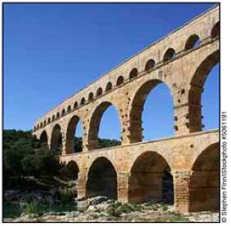
- What was the purpose of the structure in the picture above?
  - To make travel easier
  - To carry water
  - To practice a religion
  - To defend a city

------------------------------------------------------------------------------------------------------------

- Emperor Constantine influenced the traditions of Western civilization by…
  - Sending Roman soldiers to the Middle East
  - Legalizing Christianity within the Roman Empire
  - Codifying Roman law in the Middle East
  - Unifying Europe by founding the Holy Roman Empire

------------------------------------------------------------------------------------------------------------

- Which city was an obstacle to early Rome’s control of the Mediterranean region?
  - Athens
  - Carthage
  - Alexandria
  - Corinth

------------------------------------------------------------------------------------------------------------

- How did Rome’s military conquests affect the economic and social structures of the Roman Republic?
  - Slavery became important to Rome’s agricultural production.
  - Soldiers deserted to join enemy armies attacking Rome.
  - Trade routes fell into disuse throughout the Republic.
  - The Republic adopted a monotheistic religion.

------------------------------------------------------------------------------------------------------------

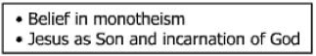
- The statements above describe the characteristics of the early…
  - Buddhists
  - Muslims
  - Zoroastrians
  - Christians

------------------------------------------------------------------------------------------------------------

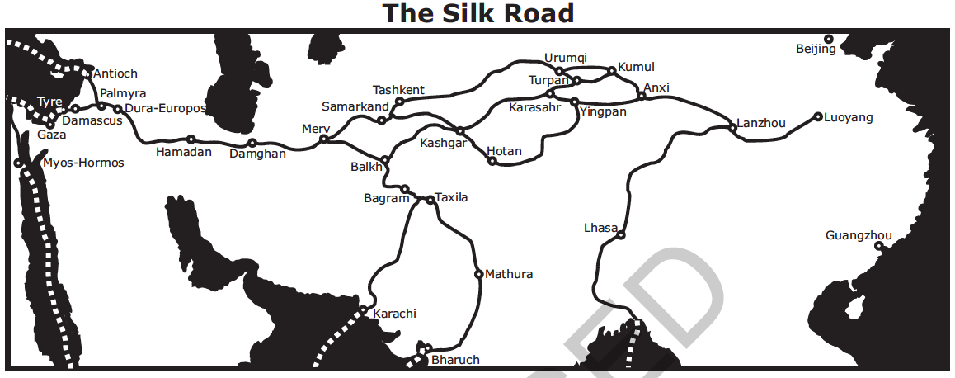
- According to the map above, how was the Silk Road associated with the development of cities?
  - Increased trade along this route helped to establish cities within major empires.
  - The development of many cities created a need for better roads.
  - The Silk Road was built as an alternative to trade between large cities by the sea.
  - European governments promoted free trade between major cities.

------------------------------------------------------------------------------------------------------------

“Litter of the past is the basis of archaeology. The coins, the pottery, the textiles and the buildings of bygone eras offer us clues as the how our (early ancestors) behaved, how they ran their economy, what they believed in and what was important to them. What archaeologist retrieve from excavations are images of past lives…. (These images) are pieced together slowly and painstakingly from the information contained in objects found.”

Richard Leakey in The Making of Mankind

- According to Richard Leakey, what is the job of the archaeologist?
  - To study coins to learn about an economy
  - To clean out caves where early ancestors lived
  - To create images of coins, pottery and textiles
  - To examine artifacts found at a location

- What term applies to the behaviors, economic activities, and beliefs referred to by Richard Leakey?
  - Culture
  - Civilization
  - Case study
  - Artifacts

------------------------------------------------------------------------------------------------------------

“The epilogue laws of justice which Hammurabi, the wise king, established; a righteous law, and pious statute did he teach the land….the decisions which I have made will this inscription show him; let him rule his subjects accordingly, speak justice to them, give right decisions, root out the miscreants and criminals from this land, and grant prosperity to his subjects. Hammurabi, the king of righteousness, on whom Shamash has conferred right (or law) am I. My words are well considered; my deeds are not equaled; to bring low those that were high; to humble the proud, to expel insolence.”

Code of Hammurabi, Epilogue

- How did implementation of codified laws such as the Code of Hammurabi affect the people of ancient societies?
  - It unified the various peoples and laws within the empire.
  - It reduced the authority of the king over the citizens.
  - It limited the role of government in the lives of citizens.
  - It established the separation of government and religion.

------------------------------------------------------------------------------------------------------------

“The Lord of the Fishes, He Who Makes the marsh birds to Go Upstream. There are no birds which come down because of the hot winds. He who makes barley and brings emmer (a kind of wheat) into being, that he may make the temples festive. If he is sluggish, then nostrils are stopped up, and everybody is poor. If there be thus a cutting down in the food offerings of the gods, then a million men perish among mortals, covetousness is practiced, the entire land is in a fury, and great and small are on the execution block…. When he rises, then the land is in jubilation, then every belly is in joy, every backbone takes on laughter, and every tooth is exposed.”

“Hymn to the Nile,” from Ancient Near Eastern Texts

- What natural phenomenon does the Lord of the Fishes represent?
  - Volcanic action
  - Monsoons
  - The Annual flooding of the Nile
  - A major fish kill

- Why are the people happy when the Lord of the Fishes comes to them?
  - The wars they fight will be over.
  - They will have food to eat.
  - Corruption will stop.
  - There will be a new pharaoh.

------------------------------------------------------------------------------------------------------------

“Then all the elders of Israel gathered together and came to Samuel at Ramah, and said to him, ‘…appoint for us, then a king to govern us, like other nations.’…Samuel prayed to the Lord, and the Lord said to Samuel, ‘Listen to the voice of the people in all that they say to you; for they have not rejected you, but they have rejected me from being king over them. Just as they have done to me, from the day I brought them up out of Egypt to this day, forsaking me and serving other gods, so also they are doing to you.’”

1 Samuel 8:4-8

- What seems to be the writer’s reaction to the Hebrews’ demand for a king?
  - Approval c. Indifference
  - Disapproval d. Amusement

- Who does this passage say was Israel’s real king?
  - Samuel c. Moses
  - The Lord d. Solomon

------------------------------------------------------------------------------------------------------------

“Guide the people with governmental measures and control or regulate them by the threat of punishment, and the people will try to keep out of jail, but will have no sense of honor or shame. Guide the people by virtue and control or regulate them by li (moral rules and customs), and the people will have a sense of honor and respect.”

Confucius, Analects 2.3

- Which phrase best describes Confucius’s belief about human nature and lawful behavior?
  - People are naturally moral and can control their behavior on their own.
  - People are best controlled by fear.
  - People learn good behavior by example.
  - People cannot be controlled by any means.

- Which of the following rulers might have held a similar belief to the quote above?
  - Shi Huangdi c. King Ashurbanipal
  - Cyrus d. Ramses II

------------------------------------------------------------------------------------------------------------

“Where ought the sovereign power of the state to reside?...The state aims to consist as far as possible of those who are alike and equal, a condition found chiefly among the middle section….The middle class is also the steadiest element, the least eager for change. They neither cover, like the poor the possessions of others, nor do others covert their, as the poor covet those of the rich….Tyranny often emerges from an over-enthusiastic democracy or from an oligarchy, but much more rarely from middle class constitutions.”

Aristotle, Politics

- Why does Aristotle support the middle class as the location of power?
  - He finds poor people too backward to rule.
  - He thinks the rich are too greedy.
  - The middle class is very enthusiastic about democracy.
  - The middle class is steady and is less eager for change.

- According to Aristotle, what often emerges from an “over-enthusiastic democracy”?
  - Tyranny c. Monarchy
  - Oligarchy d. Aristocracy

------------------------------------------------------------------------------------------------------------

“He who trusts any man with supreme power gives it to a wild beast, for such his appetite sometimes makes him; passion influences those in power, even the best of men, but law is reason without desire….”

Aristotle

- Which feature of modern Western democratic government reflects Aristotle’s views as given above?
  - The direct election of members of the legislature
  - The power of the courts to review the law
  - The granting of emergency powers to the chief executive
  - The requirement that government actions must adhere to the law

------------------------------------------------------------------------------------------------------------

“Whereas the divine providence that guides our life has displayed its zeal and benevolence by ordaining for our life the most perfect good, bringing to us Augustus, whom it has filled with virtue for the benefit of mankind, employing him as a savior for us and our descendants, him who has put an end to wars and adorned peace;… and the birthday of the god (Augustus) is the beginning of all the good tidings brought by him to the world.”

Decree from the Roman Province of Asia

- Based on the passage, the author of the decree…
  - Greatly approved of the rule of Augustus.
  - Feared the amount of power Augustus had.
  - Considered Augustus’s birthday a national holiday.
  - Thought Augustus should grant Asia its independence.

- During which period in Roman history was this passage most likely written?
  - The Punic Wars
  - The Pax Romana
  - The founding of the Republic
  - The fall of the Western Empire

------------------------------------------------------------------------------------------------------------

“Kalinga was conquered by his Sacred and Gracious Majesty when he had been consecrated eight years. 150,000 persons were thence carried away captive, 100,000 were slain, and many times that number died….Thus arose his Sacred Majesty’s remorse for having conquered the Kalingas, because the conquest of a country previously unconquered involves the slaughter, death, and carrying away captive of the people.”

Asoka in A History of Modern India by Percival Spear

- Why was Asoka remorseful about the campaign against Kalinga?
  - His army was not victorious.
  - The battle took too long to fight.
  - Many people were killed or made captives.
  - He was not able to play a more active role in the battle.

- What did the conquest of Kalinga cause Asoka to realize about the nature of war?
  - War leads to the deaths of innocent people.
  - War is the best means possible to expand an empire.
  - War cannot be avoided.
  - War is very expensive to fight.

------------------------------------------------------------------------------------------------------------

“Small axes are imported, and adzes and swords; copper drinking-cups, round and large; a little coin for those coming to the market; wine of Laodicea (on the Syrian coast) and Italy, not much; olive oil, not much;…there are imported Indian cloth called monache’ (fine quality cotton) and that called sagmotogene (probably tree cotton).”
Adapted from Travellers in Ethiopia edited by
Richard Pankhurst

- According to this passage, trade goods came to Aksum from which continents?
  - Africa, Asia, and South America
  - Asia and Europe
  - Europe and Africa
  - Africa, Asia, and Europe

- What reason might be cited for the importing of cotton cloth?
  - Cotton cloth was cheap and plentiful.
  - Cotton cloth was popular with Aksumites.
  - There was little or not cotton production in the country of Aksum.
  - It is not possible to determine a reason from the passage.

------------------------------------------------------------------------------------------------------------

“Its U-shaped temple opens east toward the nearby Mosna River and the rising sun. The sacred precinct faces away from the nearby prehistoric settlement, presenting a high, almost menacing wall to the outside world. The entire effect is of mystery and hidden power….Worshippers entered the sacred precincts by a roundabout route, passing along the temple pyramid to the river, then up some law terraces that led into the heart of the shrine. Here they found themselves in a sacred landscape set against a backdrop of mountains. Ahead of them lay a hidden place where the axis of the world passed from the sky into the underworld, an oracle famous for miles around.”

Brian Fagan, quoted in The Peru Reader

- How might visitors have felt upon entering this shrine for the first time?
  - Amused c. Arrogant
  - Awestruck d. Angry

- What effect might this shrine have had on the influence of the Chavin culture in the region?
  - Helped spread culture’s influence
  - Limited its influence
  - Shrine had no effect on spread of culture
  - Undermined importance of the culture

